Christian Clark

CIS 123

CH10 Screenshots

1. Macro1.asm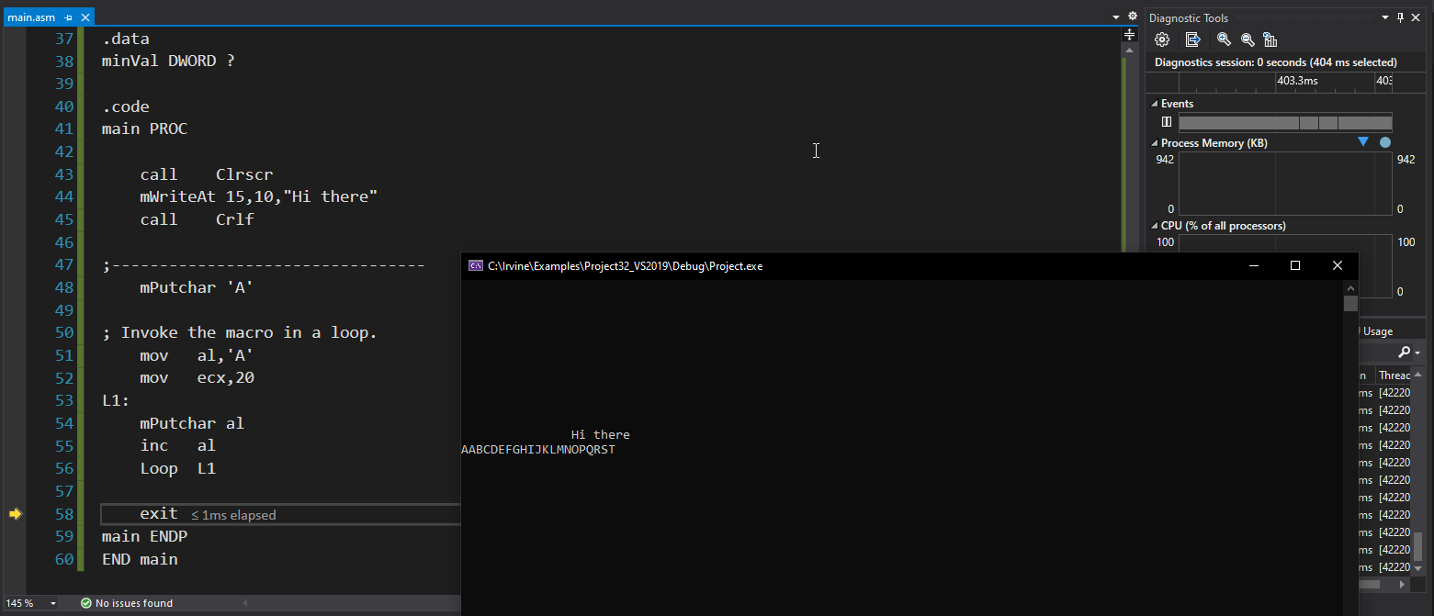

2. Fibon.asm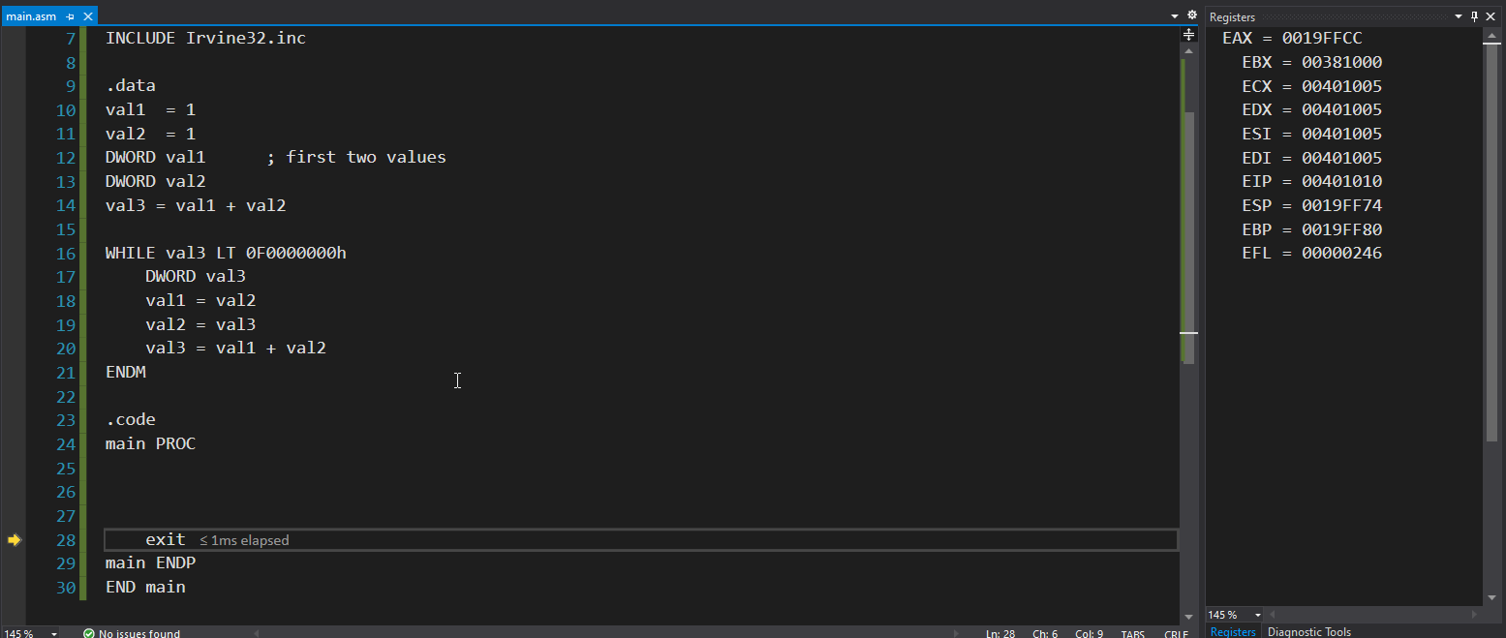

3. AllPoints.asm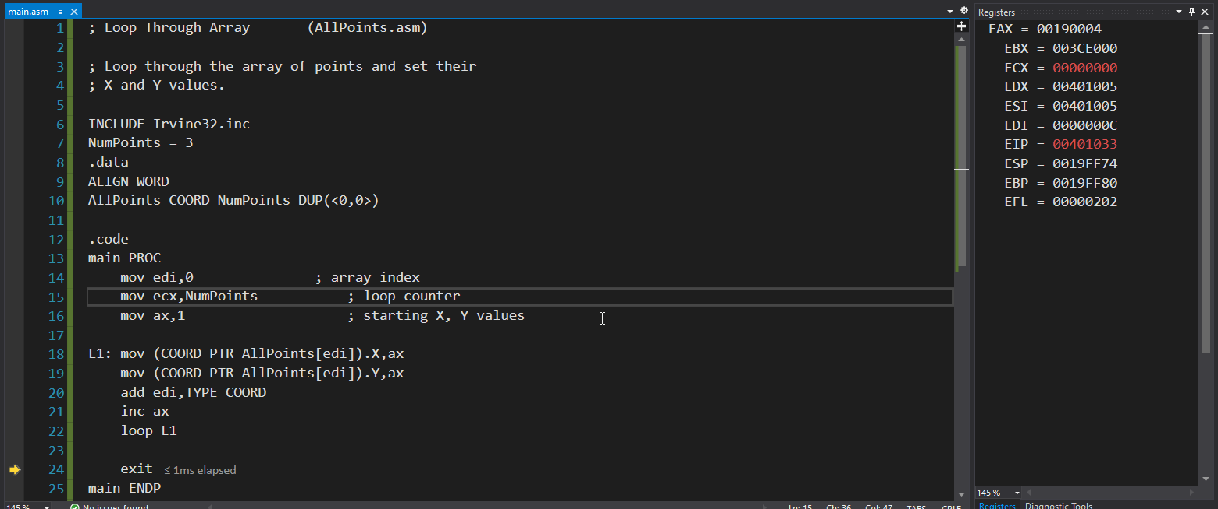

4. Struct2.asm (Struct1.asm crashes) 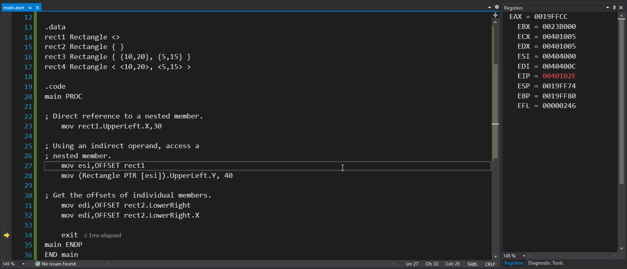

5. RowSum.asm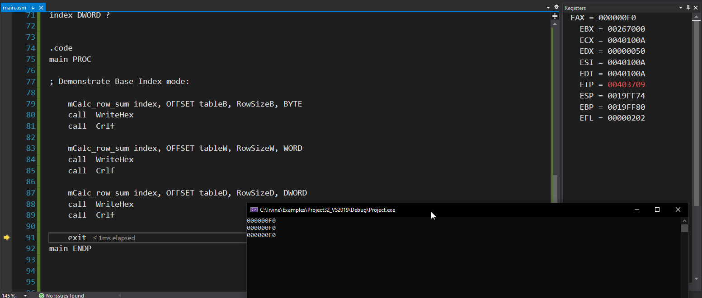

6. ShowTime.asm